# 1.EXPLAINING VARIOUS METHODS IN CONSOLE METHOD

The console method has various methods in it to perform specific operations in an unique way. They are as follows

1. Console.log()-🡪

It is used to print data to the user console or any variable data defined before it.

**EXAMPLE:**

Console.log(“umesh”) prints string umesh to user console

And same as var a=2

Console.log(a) prints 2 to user console

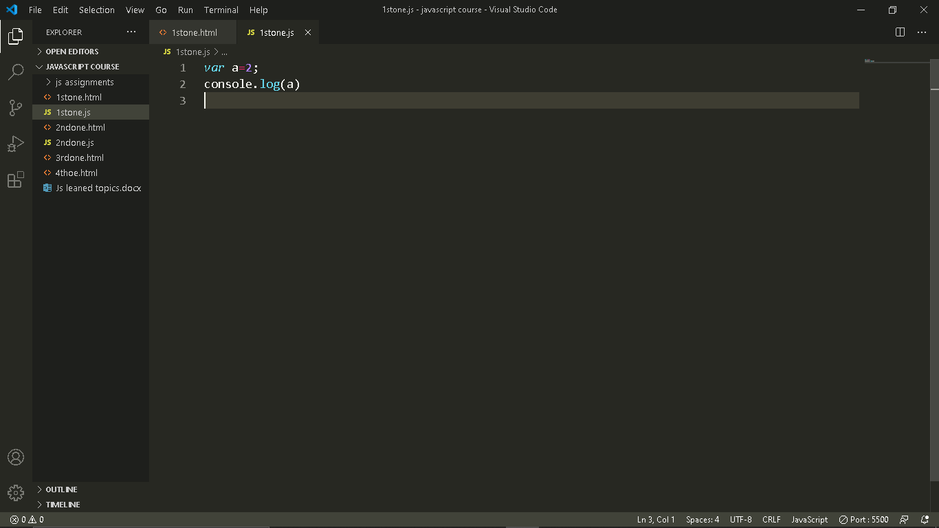

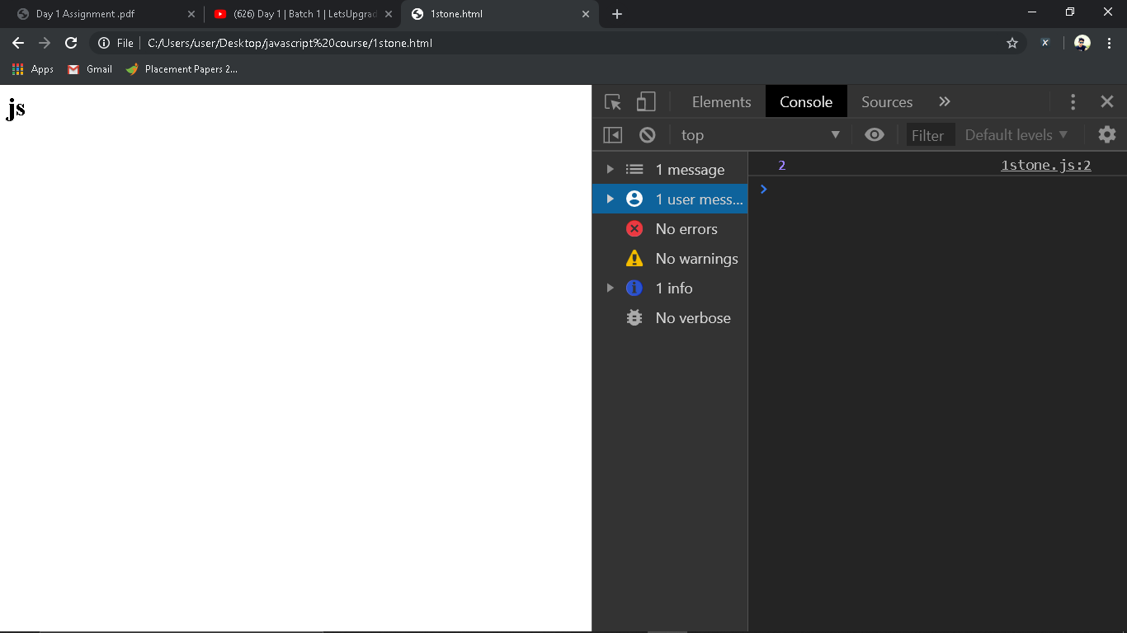

1. Console.warn()🡪

It is used to get warnings for wrong action of user at console level

**EXAMPLE:**

Console.warn(‘this is a warning’) produces a warning at user console

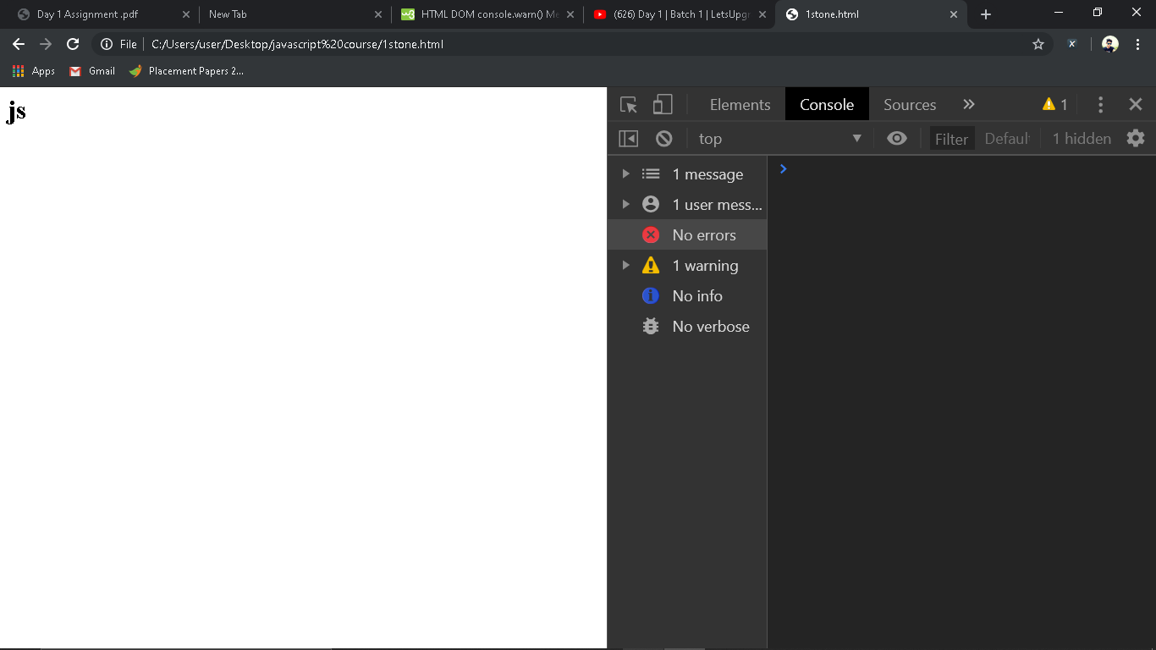

3.console.error()🡪

It is used to get errors for wrong action of user at console level

**EXAMPLE:**

Console.error(‘this is a error’) produces a error at user console

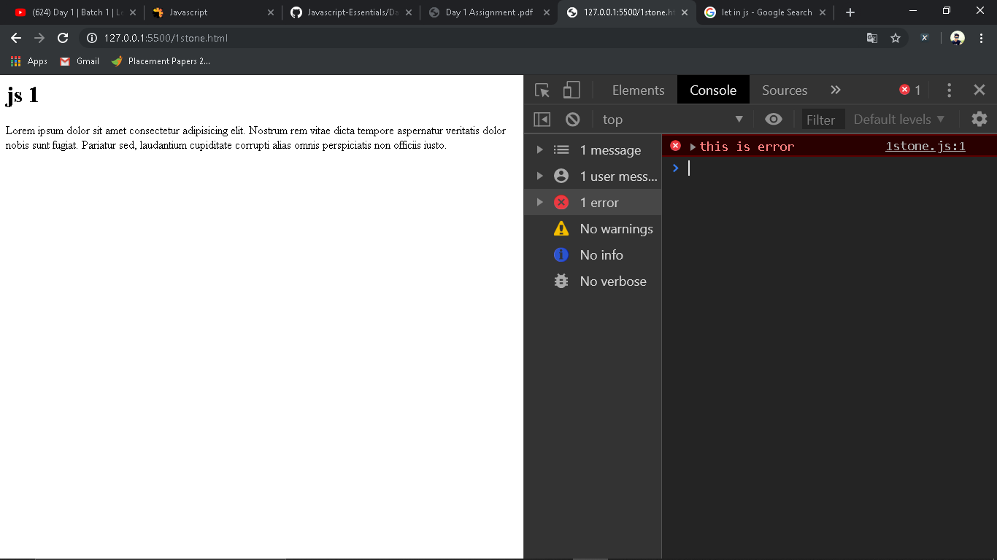

4.console.time()&console.timeend()🡪

The console.time() method starts the timer and the console.timeEnd() method ends the timer and writes the result in the console view.

console.time()

*var* x=5

*var* y=665563

*var* z=x*y

console.log(z)

console.timeEnd()

**output:**

3327815

1stone.js:7 default: 0.286865234375ms

5.console.clear()🡪

Console.clear() deletes all the data present in the cosole

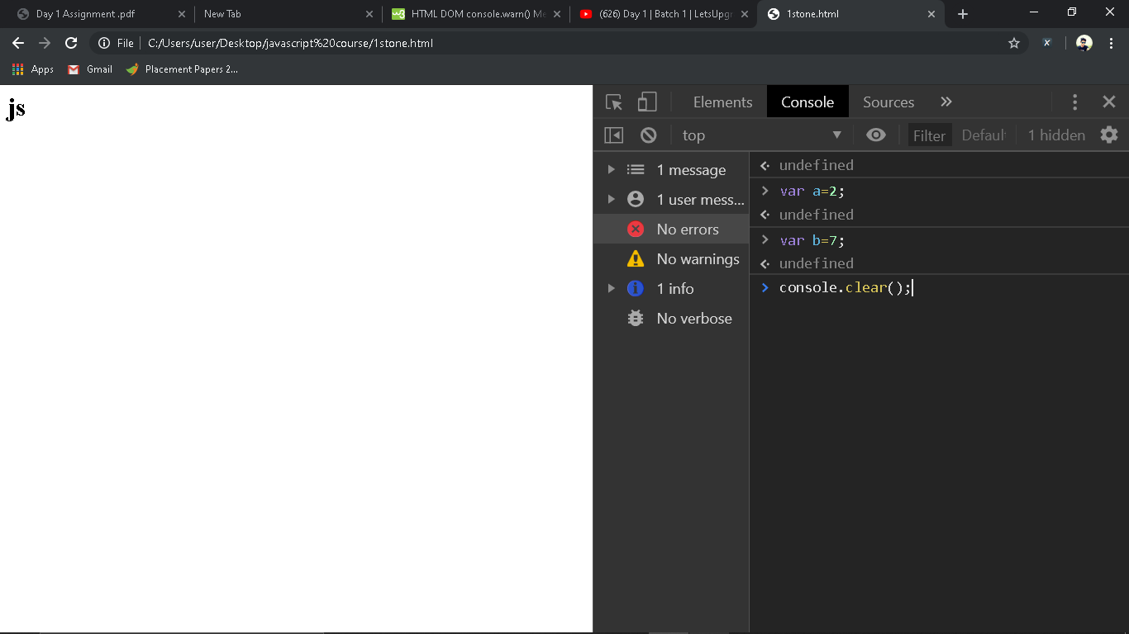

# DIFFERENCE BETWEEN VAR,LET AND CONST

**VAR:**

Var keyword is used to declare a variable and the value of variable is not fixed and it may change according to user input

**EXAMPLE:**

*var* x="umesh"

*var* y=5

*var* z=x+y

console.log(z)

**Let:**

let keyword allows us to declare a variable for a limited scope i.e for a block of statements its value cant be accesed outside the block for which it is declared.

**EXAMPLE:**

*var* name="saiumesh1"

{

*let* name="sai umesh"

    console.log(name)

}

console.log(name)

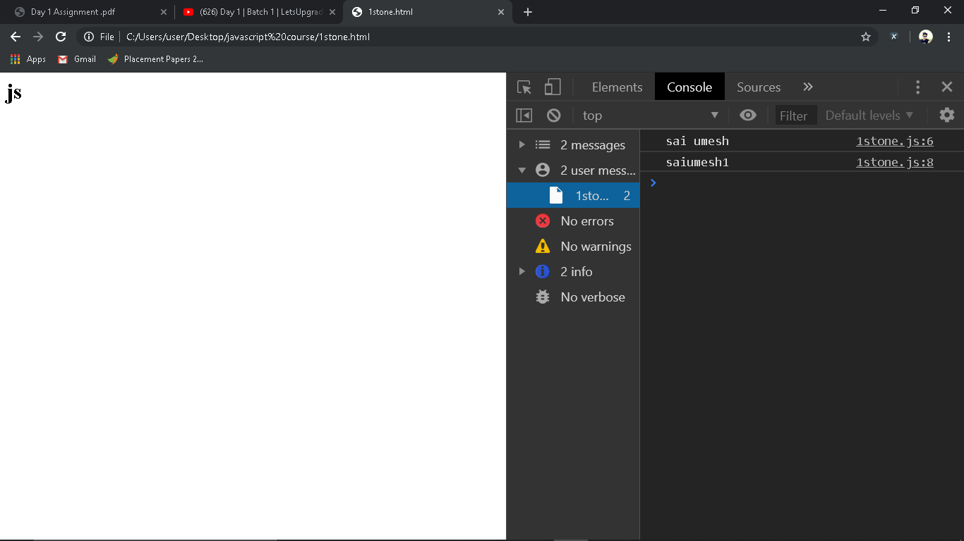

**Const:**

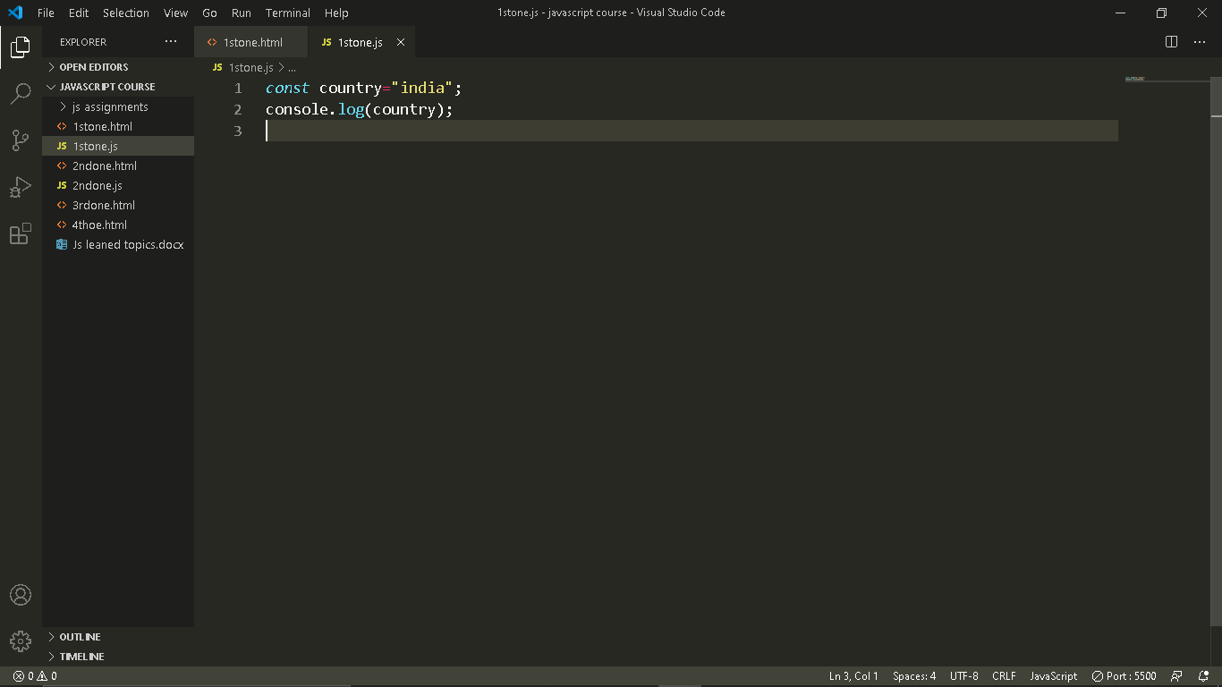

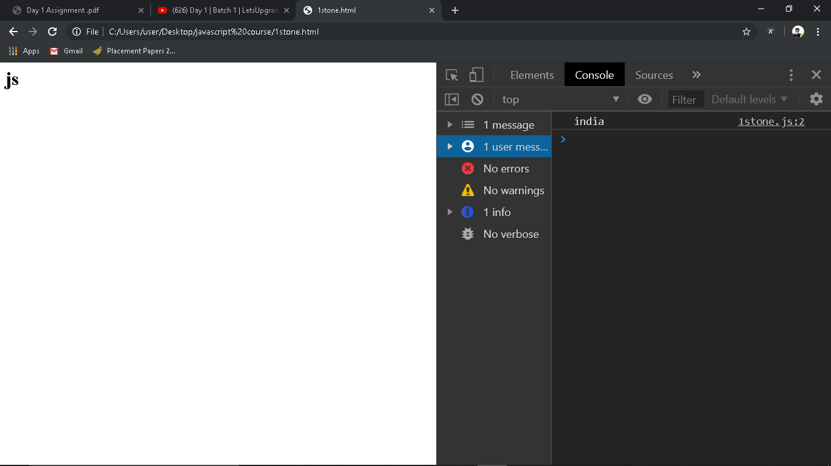

# AVAIABLE DATATYPES IN JAVASCRIPT:

1.Boolean: Boolean represents a logical entity and can have two values: true and false

2.Null type: the Null type has exactly one value: null.

3.string: it is a combination of characters and elements

4.object: var x={firstname:”sai”,lastname:”umesh}

5.number : var x=7